**Nama :Muhamad Arizal Maulana**

**NIM : 2402876**

**Kelas : 1B – Teknik Komputer**

**Praktikum 1**

**Coba 1**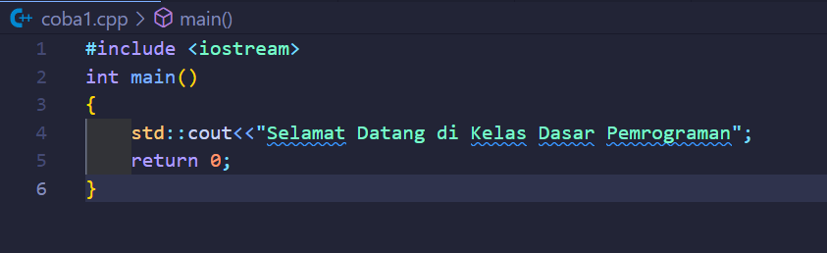

**Coba 2**

**Coba 3**

**Coba 4**

**Coba 6**

**Coba 7**

